Lesson Title: Save the Bears

Grade Level: First Grade | Quarter: 4
Standards:

Science
S1L1b Basic Needs of Animals
Identify the basic needs of an animal.
Air, Water, Food, Shelter

MGSE1.MD.1 Order three objects by length; compare the lengths of two objects indirectly by using a third object.
MGSE1.G.2 Compose two-dimensional shapes (rectangles, squares, trapezoids, triangles, half-circles, and quarter-circles) or three-dimensional shapes (cubes, right rectangular prisms, right circular cones, and right circular cylinders) to create a composite shape, and compose new shapes from the composite shape.1 This is important for the future development of spatial relations which later connects to developing understanding of area, volume, and fractions.
Lesson Essential Question:  How can you create a safe bridge for as many bears as possible to get to the other side of the river where their food is?  How does a habitat provide for an animal’s basic needs?  How can you create a safe passage for the animal to get their food?  How can I partition cylinders and rectangles to create a stable structure? | Vocabulary:  Shelter, motion, growth, safe, passage, food, stable,crimped, structure
Lesson Materials:  Straws  Scissors  Tape  toy bears  cup | Lesson Assessment:  Student journal notes  Teacher Observations
STEM Challenge Overview:
The Smyrna City Zoo needs to create a safe bridge for as many bears as possible to get to the other side of the river to their food source. How many bears will your bridge hold?

Teacher Background:
This unit is intended to test engineering skills
Only for teachers video!!!!

http://www.bing.com/videos/search?q=staws+bridge+building+&&view=detail&mid=3576D9EDD3A466E64A3C3576D9EDD3A466E64A3C&FORM=VRDGAR

INSTRUCTION
- Ask/Engage
What do all animals need to survive?
What do all bears need to survive?
If there is a river at your zoo and you need animals to get from point A to Point B, what could you build?
When you went to the zoo last month you saw many animals.

The Smyrna City Zoo needs to create a safe bridge for as many bears as possible to get to the other side of the river to their food source. How many bears will your bridge hold?

- Imagine/Brainstorm (Day Two- 20minutes)
Use your paper to draw and label how your bridge is going to look like

Criteria:
1. The bridge must support as many bears as possible. Add one bear at a time until the bridge collapses.
2. The bridge will be suspended on two similar supporting structures—Like two chairs or two tables.
3. Straw may be crimped and slipped together.
Constraints:
1. No straws may touch the floor or other supporting structures.
2. Students must use the container (cup) provided to rest on the top of the bridge to hold the bears.
3. The bridge cannot be taped to the testing area.
4. Groups of 4 students - 6 teams per class- 25 straws maximum can be used per team.
5. 20 minutes to build.

- Plan/Design
Students will collaborate with their partner and decide on a final design plan after each person has had a chance to explain their design plan.
- Create / Test
Students should build their bridges and make sure that it meets all of the criteria and constraints. After completion, students will count how many bears it can hold. If students designs fail in the testing phases of the lesson they will go back to plan a new bridge.
- Evaluate/Improve – and repeat Steps 1-5
Students should evaluate their bridge and make sure that they have completed all of the necessary components of their challenge. They should complete any missing pieces. Students should work together to put all of the bridge together in a layout that is safe for animals.

Group Member Names: ______________________________________
______________________________________
______________________________________
______________________________________
Save the bears!
1st Grade STEM Challenge

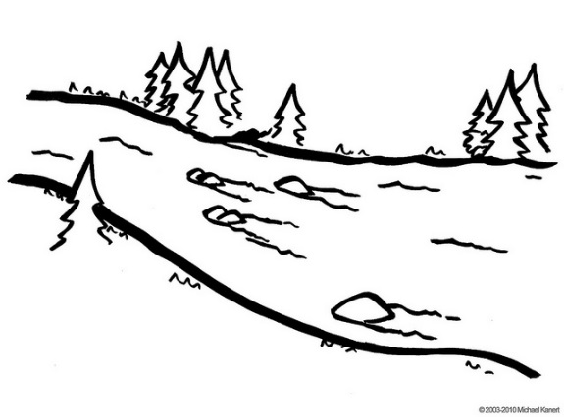

STEM Challenge:
The Smyrna City Zoo needs to create a safe bridge for as many bears as possible to get to the other side of the river to their food source. How many bears will your bridge hold?

Criteria:
- The bridge must support as many bears as possible. Add one bear at a time until the bridge collapses.
- The bridge will be suspended on two similar supporting structures—Like two chairs or two tables.
- Straw may be crimped and slipped together.

Constraints:
1. No straws may touch the floor or other supporting structures.
2. Students must use the container (cup) provided to rest on the top of the bridge to hold the bears.
3. The bridge cannot be taped to the testing area.
4. Groups of 4 students - 6 teams per class- 25 straws maximum can be used per team.
5. 20 minutes to build.

Materials:
- 25 Straws
- Scissors
- 3 feet of tape
- Cup
