Lesson Title: Snowman Houses
Grade Level: 3rd | Quarter: 4th
Standards:

Science:
S3P1. Students will investigate how heat is produced and the effects of heating and cooling, and will understand a change in temperature indicates a change in heat.
b. Investigate how insulation affects heating and cooling.
d. Use thermometers to measure the changes in temperatures of water samples over time

Habits of Mind:
CS6- Students will question scientific claims and arguments effectively.

Math:
MGSE3.MD.1 Tell and write time to the nearest minute and measure time intervals in minutes. Solve word problems involving addition and subtraction of time intervals in minutes, e.g., by representing the problem on a number line diagram.

MGSE3.MD.2 Measure and estimate liquid volumes and masses of objects using standard units of grams (g), kilograms (kg), and liters (l). Add, subtract, multiply, or divide to solve one-step word problems involving masses or volumes that are given in the same units, e.g., by using drawings (such as a beaker with a measurement scale) to represent the problem.

Lesson Essential Question:  - How does insulation affect the heating and cooling of ice?  - How do I measure liquid volumes?  - How do I measure time intervals? | Vocabulary:  - Heat  - Insulation  - Liquid Volume  - Time Intervals
Lesson Materials:  - Book- Snowmen All Year by Caralyn Buehner  - Rulers, tape, scissors, graduated cylinder, ice, stopwatch, cooler, 1 small plastic bowl/ group, funnel  Suggested materials for team designs:  - aluminum foil, plastic wrap, wax paper  - paper, paper towels  - styrofoam pieces  - clay  - felt, wool, cotton, cloth  - craft sticks  - card board pieces | Lesson Assessment:  - Student Journals  - Teacher observations  - Data Chart (attached)
STEM Challenge Overview:

Students will design a house to place around a “snowman” made of ice to keep it from melting.

Teacher Background:

Students should have investigated how heat is produced and the effects of heating and cooling. Student should understand that a change in temperature (increase or decrease) indicates a change in heat.

Prep before the challenge:
- Teachers will need to use ice cube trays to make the ice or bring ice in from your house. Machine ice is too small. Each team will need 1 large ice cube.

INSTRUCTION
- Ask/Engage
Day 1 (30-45 min.)
- Read: Snowmen All Year by Caralyn Buehner or watch the YouTube video: Video: https://www.youtube.com/watch?v=92G6k81Mfgw
- After reading, ask the students if they have ever made a snowman before? If so, ask how long did it last before it melted? If you could take a snowman anywhere, where would it be? What would you do with your snowman?
- Hand each student a piece of ice to hold in their hands. Using stop watches, time how long it takes the ice to melt from a solid to a liquid. Teacher should create a line plot of the class’s results on the board. As the ice is melting ask questions about how it feels. Ask: What caused the ice to melt? How do you think we could prevent the ice from melting?
- Introduce the vocabulary word- insulation and discuss what insulation does (prevents heat from escaping) and examples of heat insulators (coolers, oven mitts, thermos, house insulation…..). Teacher may provide examples for the students to touch and explore.
- Introduce the challenge.
Challenge:
Since snow is very uncommon in Georgia, building a snowman is a special treat! What if you could keep your snowman around for a longer? Using your knowledge of heat, insulators and conductors, as a team design a house that would help your snowman from melting.
- Imagine/Brainstorm
Day 2 (30-45 min.)
Introduce the challenge, criteria and constraints to the students.
Have students work independently to come up with 1-2 possible design solutions and draw/label their designs.

Criteria:
- House must fit around the bowl provided
- Nothing can be placed inside the bowl to absorb the melted water
- House needs to keep the snowman from melting

Constraints:
- House may not be attached to the bowl
- May only use the materials provided
- Must complete the challenge in the time allotted

- Plan/Design
Day 2 Continued
- Each student presents their ideas to their team.
- Teams collaborate to come up with final design plan.
- Teams draw and label their final design plan and make a list of supplies they will use.

- Create / Test
Day 3 (one hour)
- Teams build their design according to their plan. For test 1 give the team’s 30-40 minutes to build their design.
- When time is called give each team an ice cube to place inside their bowl. Allow the ice cubes to sit in the bowls for 10 minutes. As you are waiting to get the melted ice results, have each team share their design with the class, how they came up with their design and what materials they used in their design.
- Teams will test their designs when time is called by putting the funnel into the graduated cylinder and pouring the melted water from the bowl into the graduated cylinder. They will then measure and record the amount of melted water using mL.
- Once all of the measurements of water are listed, each student will create a line plot displaying the class data.
- As a team the students will brainstorm ideas to improve their design.

- Evaluate/Improve – and repeat Steps 1-5
Day 4 (30-45 min.)
Students evaluate their design for success: Did it meet the established criteria? Did their final design match their planned design? How would students improve their design?

Allow students time to improve their designs. Access to more materials may be necessary and additional snowmen will need to be made.

When time is called, have students test how much water melted the second time after improving their designs.

The teacher should record the results to see how many teams improved their designs.

At the end of the challenge, the students should reflect on which materials made the best insulators. Which designs worked best? Why? Students should make a claim and support it with scientific evidence.

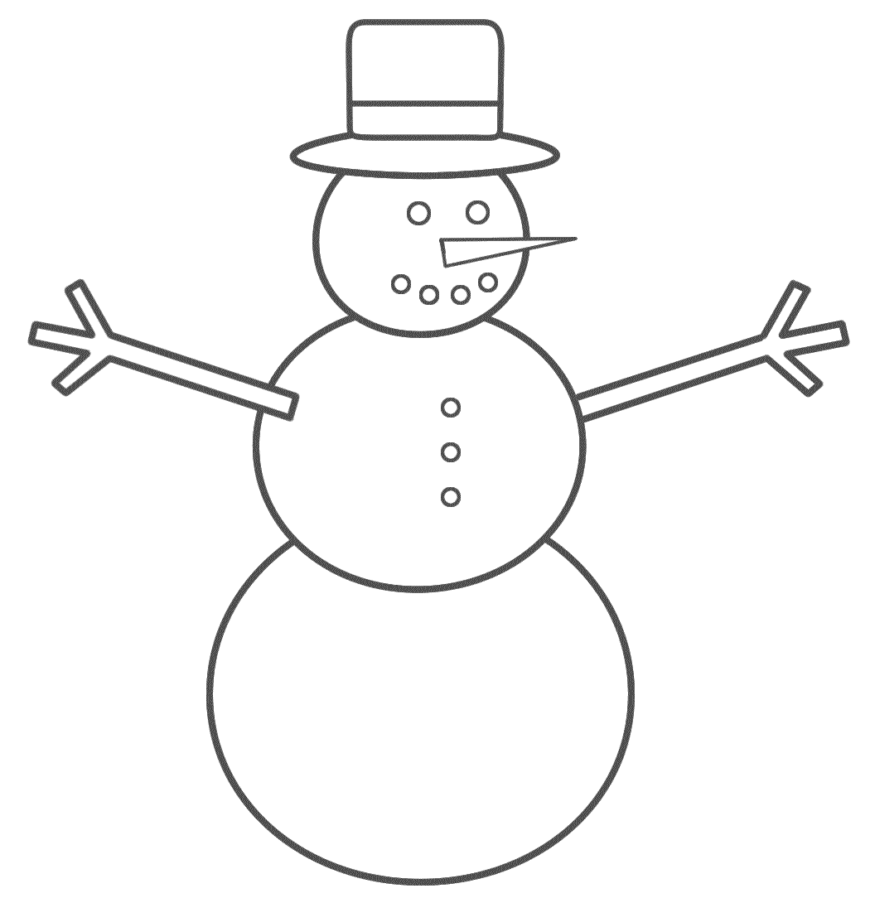
Name__________________

Snowman Houses STEM Challenge
3rd Grade

Challenge:
Since snow is very uncommon in Georgia, building a snowman is a special treat! What if you could keep your snowman around for a longer? Using your knowledge of heat, insulators and conductors, as a team design a house that would help your snowman from melting.
Criteria:
• House must fit around the bowl provided
• Nothing can be placed inside the bowl to absorb the melted water
• House needs to keep the snowman from melting

Constraints:
• House may not be attached to the bowl
• May only use the materials provided
• Must complete the challenge in the time allotted

Materials:
Suggested materials for team designs:
- aluminum foil, plastic wrap, wax paper
- Paper, paper towels
- Styrofoam pieces
- Clay
- Felt, wool, cotton, cloth
- Craft sticks
- Pieces of cardboard

- ASK / ENGAGE: What is the problem you are being asked to solve?
________________________________________________________________________________________________________________________________________________________________________________________________________________________________________________________________________________________________________________________________________________________________________________________________________
- IMAGINE/BRAINSTORM: What are some possible solutions to the problem that you are trying to solve? After you brainstorm, draw and label your ideas below.
Idea #1 | Idea #2
- PLAN/DESIGN: Share your ideas with your group and collaborate to decide on a final design plan. Draw your team’s design below and make a list of the materials that you will need to complete your design.
Team Design Plan | Materials List

- CREATE/TEST: Use your Final Design Plan to create and build your solution. Test your design. Did it work? Why or Why not?
____________________________________________________________________________________________________________________________________________________________________________________________________________________________________________________________________________________________________________________________________________________________________________________
- EVAULATE/IMPROVE: How well did your design work? Did your solution solve the problem within the given constraints?
____________________________________________________________________________________________________________________________________________________________________________________________________________________________________________________________________________________________________________________________________________________________________________________________________________________________________________________________________________________________________________________________________________________________________________________________________________________________________________
How can you improve your design? How can you make it better? Draw and label your improved design below.
Improved Design Plan

Snowman House Test 1 and 2

Team # | Test 1 (mL) | Test 2 (mL) | Difference
1
2
3
4
5
6

Which team had the least amount of water melt? _______
Which team had the greatest amount of water melt? _______
Which team made the best improvement to their design? _______

