Lesson Title: Animal Engineering
Grade Level: 5th | Quarter: 4th
Standards:

Science:
S5L1. Students will classify organisms into groups and relate how they determined the groups with how and why scientists use classification.
a. Demonstrate how animals are sorted into groups (vertebrate and invertebrate) and how vertebrates are sorted into groups (fish, amphibian, reptile, bird, and mammal).

Math:
MGSE5.NBT.5 Fluently multiply multi-digit whole numbers using the standard algorithm.
MGSE5.NBT.7 Add, subtract, multiply and divide decimals to hundredths, using decimals to hundredths, using concrete models or drawings and strategies based on place value, properties of operations, and/or the relationship between addition and subtraction; relate the strategy to a written method and explain the reasoning used.

Lesson Essential Question:  - How can I use my knowledge of the classification system for living things to engineer an entirely new living creature? | Vocabulary:  Classification  Vertebrate  Invertebrate  Kingdom  Phylum  Class
Lesson Materials:  Paper core tubes from wrapping paper, paper towels, toilet paper  Cardboard  Cardstock  Lids  Plastic bottles and/or jars  Pipe Cleaners  Metal cans of assorted sizes  Craft sticks and wooden dowels  Toothpicks  Bubble wrap  Wax paper  Plastic wrap  Aluminum foil  Styrofoam  Paint  Construction Paper  Markers and/or colored pencils  Glue and/or Tape  Fake Fur and feathers  Assorted fabrics | Lesson Assessment:  Completed animal model with reference card  Competed Student Journal  Completed budget sheet- attached  Student participation
STEM Challenge Overview:

Students will design an animal for a biotechnology engineering firm which creates new animals.

Teacher Background:

Students should have been introduced to basic information about classification systems prior to this activity. A reference chart for the vertebrate and non-vertebrate phyla, with the classes for each phylum and key information for each is attached below. This chart could easily be used for an introductory lesson prior to this one, by blanking out key information and requiring students to do research to complete the chart.

The project is designed to use readily available, inexpensive recycled materials; however it is certainly an option to encourage students to bring in materials which might enhance the animal models, such as fake fur and feathers.
Students will manage an “engineering budget” of $500.

Prep: The teacher will need to assign prices to the various items in the materials “warehouse”.

INSTRUCTION
- Ask/Engage - Day 1 (15 min.)
Display the pictures of mystery animals and the taxonomical chart (all attached below) or use your own animal pictures. Ask students to discuss with their thinking partner or elbow partner how they might classify the creatures in the pictures based off the chart. Allow 2-3 students share their thoughts by giving characteristics from the chart. What type of animal are they?

Introduce the challenge and have students fill out the ask/engage part of their student journal.

Challenge:
The Amazing BioTech Engineering Company has hired a group of expert animal designers to develop a new animal for one of its clients, the Astonishing Safari Company. The Astonishing Safari Company is known around the world for its exciting animal collection which can only be viewed on very expensive tours at their parks in select locations on different continents. Your challenge is to create an animal which does not fit into the traditional classification chart for living things, because it combines characteristics from the different phyla (Vertebrate and Non-vertebrate) or classes within a phylum (for example: reptile and bird). Since Amazing BioTech Engineering Company will put a lot of money into the research and development for future projects, they have provided each group with a budget for your creature creation.

- Imagine/Brainstorm – Day 2 or Continuation of Day 1 (30-40 min.)
Each creative engineering group will be presenting an animal model to the company. Individually each student should brainstorm two ideas of an animal model which would fit the listed criteria and constraints. The brainstormed drawings should contain as many details as possible with labels or written explanations to help others understand the thinking. Generate a list of possible materials that would be needed for the ideas, along with a rough estimate of the cost.

Criteria:
1. Must be created as a model and have a unique name
2. Must combine characteristics of more than one class from vertebrate and/or invertebrate phyla
3. Must have at least 2 moveable parts
4. Must be accompanied by a reference card with the following information:
-animal’s name -body covering
- habitat -movement
- adaptations -what it eats and how it eats

Constraints:
1. Must be created from materials provided
2. Must be completed in the time allotted
3. Must keep within $500 budget for constructing the animal by completing the cost accounting sheet

- Plan/Design – Day 3 (30-45 min.)
Students will present their ideas to members of their engineering teams.

Each person in the group must help build the model and is responsible for completion of his/her own student journal.

Each team should collaboratively discuss the ideas and come up with a plan for a final design. After the plan has been agreed upon, the final plan should be drawn, a materials list created, and all costs should be listed on the budget sheet.

- Create / Test – Day 4 (45 min.)
Engineering teams will build their animal models according to their design plans.

- Evaluate/Improve (and repeat Steps 1-5) Day 5 (20 min.)
Each team should evaluate their design. Did the animal model meet the established criteria? Did the final design match the planned design? If not, why? Did the team stay within the budget? How would the team improve their design?

Mystery Animals- Where do they belong?

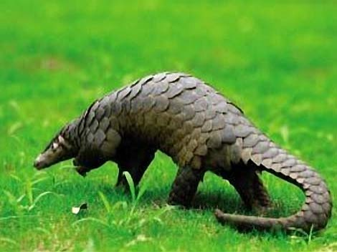
Pangolin

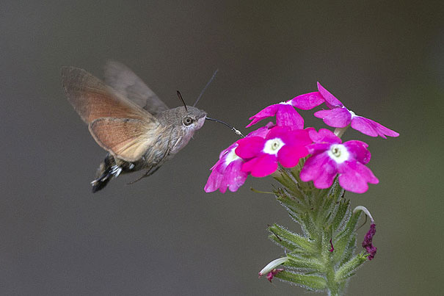
Hummingbird Hawk-Moth

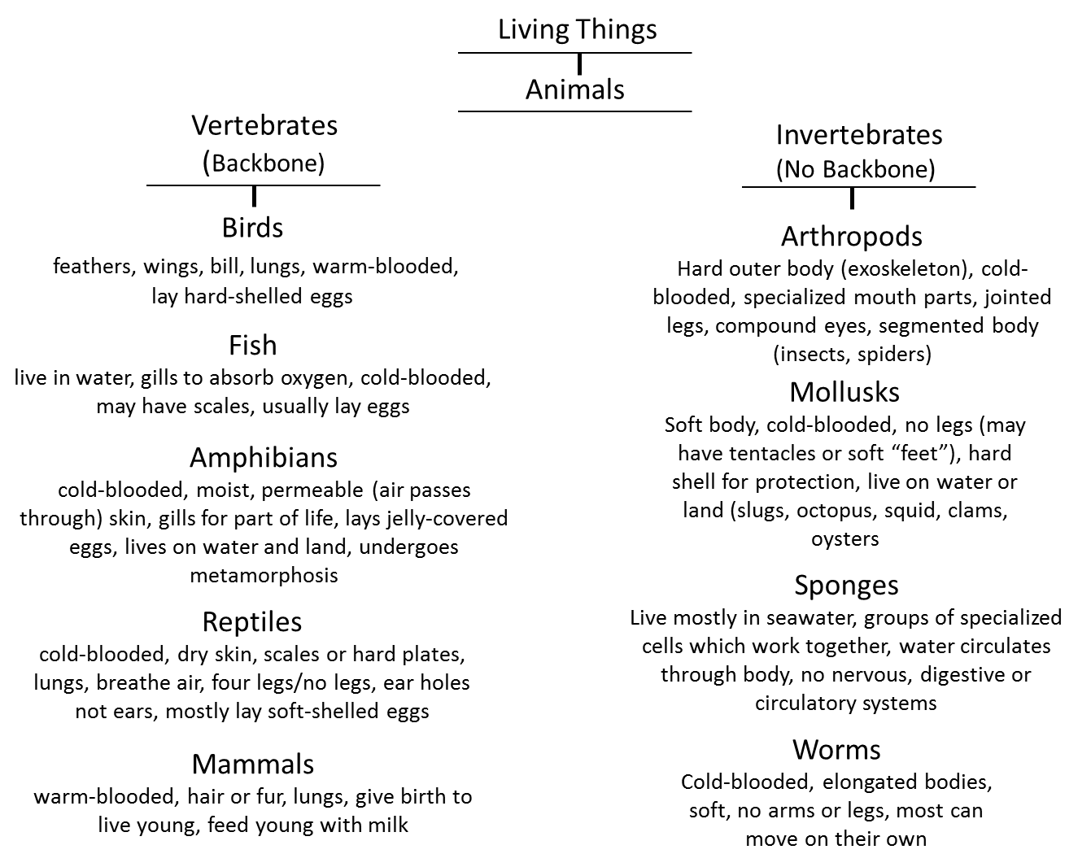
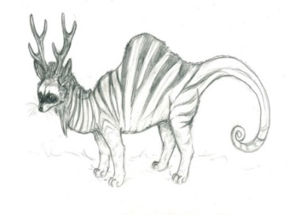
Name_________________

Animal Engineeering STEM Challenge
5th Grade

Challenge: The Amazing BioTech Engineering Company has hired a group of expert animal designers to develop a new animal for one of its clients, the Astonishing Safari Company. The Astonishing Safari Company is known around the world for its exciting animal collection which can only be viewed on very expensive tours at their parks in select locations on different continents.
Your challenge is to create an animal which does not fit into the traditional classification chart for living things, because it combines characteristics from the different phyla (Vertebrate and Non-vertebrate) or classes within a phylum (for example: reptile and bird). Since Amazing BioTech Engineering Company will put a lot of money into the research and development for future projects, they have provided each group with a budget for your creature creation.
Criteria:
1. Must be created as a model and have a unique name
2. Must combine characteristics of more than one class from vertebrate and/or invertebrate phyla
3. Must have at least 2 moveable parts
4. Must be accompanied by a reference card with the following information:
-animal’s name -body covering
- habitat -movement
- adaptations -what it eats and how it eats

Constraints:
1. Must be created from materials provided
2. Must be completed in the time allotted
3. Must keep within $500 budget for constructing the animal by completing the cost accounting sheet

Materials: provided by the teacher

- ASK / ENGAGE: What is the problem you are being asked to solve?
_____________________________________________________________________________________________________________________________________________________________________________________________________________________________________________________________________________________________________________________________________________________________________________________________________

- IMAGINE/BRAINSTORM: What are some possible solutions to the problem that you are trying to solve? After you brainstorm, draw and label your ideas below.
Idea #1 | Idea #2
- PLAN/DESIGN: Share your ideas with your group and collaborate to decide on a final design plan. Draw your team’s design below and make a list of the materials that you will need to complete your design.
Team Design Plan | Materials List

- CREATE/TEST: Use your Final Design Plan to create and build your solution. Test your design. Did it work? Why or Why not?
____________________________________________________________________________________________________________________________________________________________________________________________________________________________________________________________________________________________________________________________________________________________________________________
- EVALUATE/IMPROVE: How well did your design work? Did your solution solve the problem within the given constraints?
____________________________________________________________________________________________________________________________________________________________________________________________________________________________________________________________________________________________________________________________________________________________________________________________________________________________________________________________________________________________________________________________________________________________________________________________________________________________________________
How can you improve your design? How can you make it better? Draw and label your improved design below.
Improved Design Plan

Names: ____________________________________________________________________________________________
Project Accounting Sheet for Animal Engineering
$500 Budget

New Animal
Material | Cost for 1 | # Needed | Total
Project Total:

