Lesson Title: Light up the Night
Grade Level: 5 | Quarter: 3rd
Standards:

Science
S5P3. Students will investigate the electricity, magnetism, and their relationship.
b. Determine the necessary components for completing an electric circuit

Math
MGSE5.MD.1 Convert among different-sized standard measurement units within a given measurement system (e.g., convert 5 cm. to 0.05 m), and use these conversions in solving multi-step, real world problems.

Lesson Essential Question:  - How can I determine the necessary components for completing an electric circuit?  - How do I convert among different-sized standard measurement units? | Vocabulary:  Electricity  Closed Circuit  Open Circuit  Convert
Lesson Materials  Working strands of Christmas lights  Wire Cutters / Stripper (for the teacher)  Insulated Wire  Straws  Scissors  Card-stock paper  Electrical Tape (or masking tape)  Batteries (C or D size)  Battery holders (optional)  Rulers  Measuring Tape | Lesson Assessment:  Student STEM Journal  Teacher Observations
STEM Challenge Overview:

Students will build a working model of streetlights to present to a City Council.

Teacher Background:

This lab is set up for inquiry learning. No experience with circuits is necessary before beginning this lab.
Students work in groups of 3-4. When using insulated wire, the teacher will need to strip the ends of the wire to expose the copper. Use caution when using wire cutters to cut apart Christmas tree lights to strip the ends.
Students might need to be reminded about converting measurements when measuring the perimeter of the buildings.

INSTRUCTION
- Ask/Engage
Day 1 (35 min)
- Provide each group of students with materials to make a simple circuit; one battery, one light bulb and one wire. Allow students to explore ways to make the bulb light up. Create a large T-Chart on the board labeled Didn’t Work and Worked. Have students draw ideas that didn’t work then after groups get the light bulb to light have a teach draw and share how they got it to work. Discuss with the students how to make a simple circuit; need a circular path and metal touching metal. Provide students with more materials and allow students them to see what happens to the bulb when more electrical energy is added to the circuit. How can you get two light bulbs to light? After students have had sufficient time to explore, meet as a whole class to discuss findings.
- Share the STEM challenge.
- Have students complete the ask/engage part of their journal.
Challenge:
The City Council of Smallville would like to install streetlights down a section of Main Street. Your team has been hired to wire and install the street lights. Your task is to build a model which can be presented to the City Council for approval. Use what you’ve learned about circuits to create a model of the town to share with City Council.

- Imagine/Brainstorm
Day 2 (15 – 30 min)
Criteria:
1. Construct working streetlights in front of the town
2. Colorful, neat and presentable model
3. No wires should be visible from street level
4. Streetlamps should not be taller than the buildings
5. Measure the height of each of the buildings using two types of standard measurement. For example convert if a
building measures 5 cm it also measures 0.05 m.

Constraints:
- Use the materials provided
- Challenge needs to be completed in the time allotted

Provide an individual brainstorming opportunity for students to determine how to use their new knowledge of how to create a circuit to design a way to make the streetlights.

- Plan/Design
Day 2 Continued (10 -15 min)
Each student presents their ideas to their team. Student teams collaborate to come up with final design plan. Students draw final design plan and make a list of needed supplies.

- Create / Test
Day 3 (30 – 45 min)
Teacher prep should include pre-stripping Christmas Lights. It may be helpful to pre-cut strips of electrical tape or masking tape to make distribution easier.
Student teams build their design according to their design plan.
Students test their design plan and record data.

- Evaluate/Improve – and repeat Steps 1-5
Students evaluate their design for success. Did it meet the established criteria? Did their final design match their planned design? How would students improve their design?

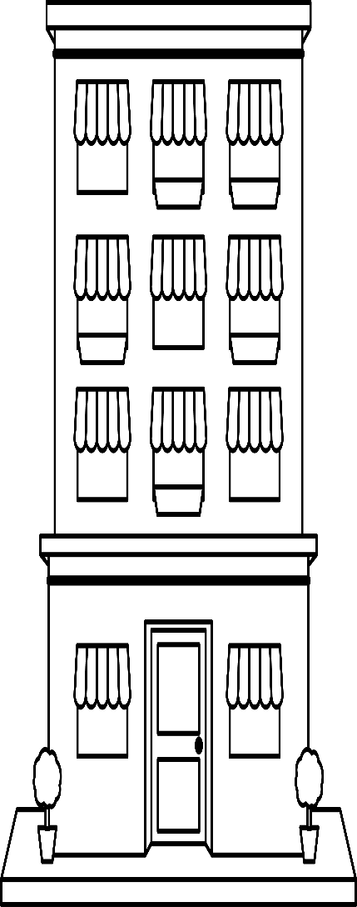
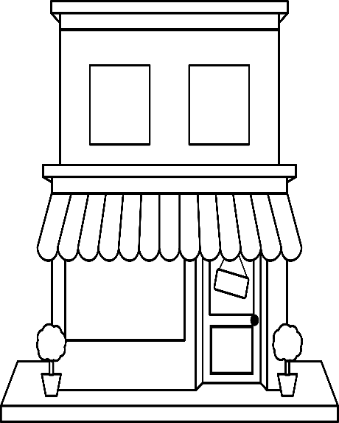

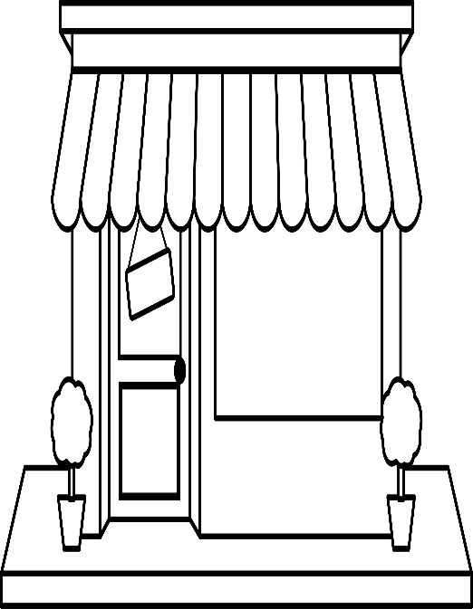

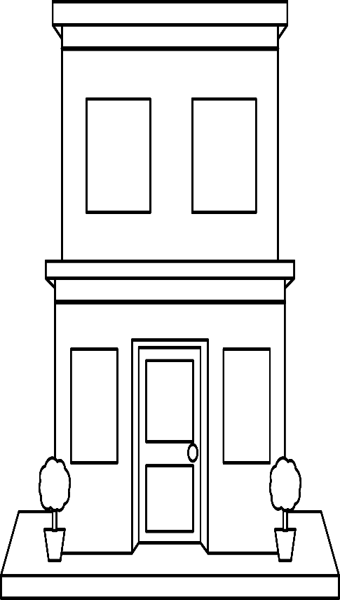

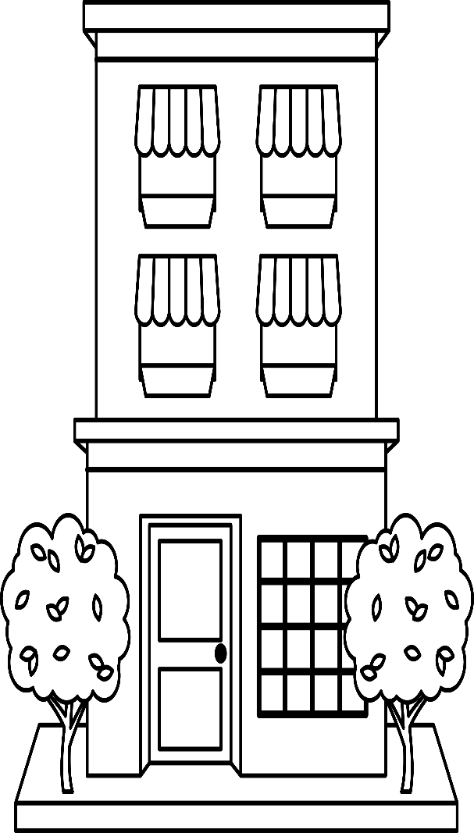
Name__________________

Light up the Night STEM Challenge
5th Grade

Challenge:
The City Council of Smallville would like to install streetlights down a section of Main Street. Your team has been hired to wire and install the street lights. Your task is to build a model which can be presented to the city council for approval. Use what you’ve learned about circuits to create a model of the town and working streetlights to share with the City Council.
Criteria:
1. Construct working streetlights in front of the town
2. Colorful, neat and presentable model
3. No wires should be visible from street level
4. Streetlamps should not be taller than the buildings
5. Measure the height of each of the buildings using two types of standard measurement. For example convert if a building measures 5 cm it also measures 0.05 m.

Constraints:
1. Use the materials provided
2. Challenge needs to be completed in the time allotted
Materials:
Use materials provided by the teacher

- ASK / ENGAGE: What is the problem you are being asked to solve?
________________________________________________________________________________________________________________________________________________________________________________________________________________________________________________________________________________________________________________________________________________________________________________________________________
- IMAGINE/BRAINSTORM: What are some possible solutions to the problem that you are trying to solve? After you brainstorm, draw and label your ideas below.
Idea #1 | Idea #2
- PLAN/DESIGN: Share your ideas with your group and collaborate to decide on a final design plan. Draw your team’s design below and make a list of the materials that you will need to complete your design.
Team Design Plan | Materials List

- CREATE/TEST: Use your Final Design Plan to create and build your solution. Test your design. Did it work? Why or Why not?
____________________________________________________________________________________________________________________________________________________________________________________________________________________________________________________________________________________________________________________________________________________________________________________
- EVAULATE/IMPROVE: How well did your design work? Did your solution solve the problem within the given constraints?
____________________________________________________________________________________________________________________________________________________________________________________________________________________________________________________________________________________________________________________________________________________________________________________________________________________________________________________________________________________________________________________________________________________________________________________________________________________________________________
How can you improve your design? How can you make it better? Draw and label your improved design below.
Improved Design Plan

