Lesson Title: Saving the Crew of the Minnow (Gilligan’s Island)

Grade Level: 2 | Quarter: 2
Standards:

S2P2b How Light, Heat and Motion Energy are Used
Describe how light, heat, and motion energy are used.

MCC2.G.1
Recognize and draw shapes having specified attributes, such as a given number of angles or a given number of equal faces. Identify triangles, quadrilaterals, pentagons, hexagons, and cubes (Sizes are compared directly or visually, not compared by measuring)

VA2MC.2
- Produces multiple interpretations for an object or image.
- Revises artwork in response to unanticipated insights and discoveries.

VA2AR.1
- Uses art terminology with emphasis on the elements of art: space, line, shape, form, color, value, texture
Lesson Essential Question:  How can wind energy be used?  How can I draw and create shapes based on specific attributes? | Vocabulary:  motion, wind, sail, energy
Lesson Materials: (these materials are optional and can be changed)  Cardboard/old cereal boxes, sand, scissors, string, weighted objects that sink (this can be used to hold down the island), corks, small plastic storage containers,  craft sticks, construction paper, thin fabric, thick fabric, straws or thin dowels, craft glue, rubber bands, small fan or hair dryer, play dough, 7 small plastic bears per group (used for counting), shallow clear tub per group, water, video camera or iPad, video clip of Gilligan’s Island’s theme song  http://www.youtube.com/watch?v=yfSLuEj99d0 | Lesson Assessment:  Group rubric (working together)  Student Journal  Teacher Observations: Did the boat make it across the water without losing any passengers?
STEM Challenge Overview:
The castaways’ adventure ended when they were stranded on an island.
- You must create a boat that will carry all seven passengers (plastic bears) back to safety. You may use any of the materials provided.
- Your boat must carry all seven passengers (plastic bears) safely across from one end of the tub to the other side. None of your passengers should fall off.
- Your design must include the following shapes; a shape with three angles, a quadrilateral, and a shape with six faces.
- You must design a background/island/ocean floor using your water and tub.

Teacher Background:
- The students will be building a sailboat utilizing wind energy. Teacher should not just tell students they are building a sailboat until discussions have lead themselves to this type of boat on day one of the lesson.
- This lesson can be completed after wind energy has been introduced and students have observed other uses of wind energy. Teacher may want to show various pictures of boats. These pictures can be found on Mackinvia.
- Also, teacher should mark the tub of water with a starting point and an ending point on the other side. Make sure students have an understanding of shapes and their attributes.
- If you do not have access to all the materials, then provide materials that will enable the students to perform the task.
- The fan or hair dryer used should be set on low or the wind will knock over the boat. Teacher should be familiar with fan speed.
- Students will create a 2-3 minute video explaining their design at the end of the activity using iPads or other recording devices.
- Discuss what an ocean floor may look like and an island (use pictures as needed).

INSTRUCTION
- Ask/Engage
Day 1: 30 minutes
- Begin the lesson with the essential question: How can wind energy be used? Students may think, pair, share. Teacher should write students’ responses on chart paper. Tell students we are going to begin a new STEM challenge in which wind energy will be used.
- Engage students by beginning the lesson with Gilligan’s Island’s video theme song. Following the song, discuss the problem the stranded passengers are facing. What is their problem? Record students’ answers on chart paper. Can we build a boat that carries the crew back to safety? What type of boat would work best?
- Show pictures of several boat designs making sure a sail boat is included. What did you observe about the boat designs? Teacher should lead discussion with students understanding that a sailboat uses wind energy.
- Discuss with students aesthetics of their boat vs function. Example: The quadrilateral they include for their design does it help with the function or just there for looks? This would be a good time to discuss how an artist makes changes as they are working on their art just like an engineer makes changes. This information is useful for students in creating their ocean, island, and background. What problems may you occur?
- Introduce the challenge:
Your group will collaboratively build a sailboat that will safely carry all seven passengers without falling into the water using wind energy.
- When Imagine/Brainstorm
Day 2: 60 minutes
- Introduce the constraints of the design plan.
Criteria:
1. Your boat must carry all seven passengers.
2. Your boat must use wind energy.
3. Your boat must have a shape with 6 equal faces, a shape with 3 angles, and a quadrilateral.
4. Your boat must travel from one side of the tub of water to the other side.
5. Using your tub, water, and materials you must create a background with an island and ocean floor.
Constraints:
1. You may only use the provided materials.
2. You must work together as a team.
3. None of your passengers can fall into the water.

- Ask each student to work independently to come up with 1-2 possible design solutions. Students should draw/label their designs.

- Plan/Design
Continued: Day 2
- Each student presents their ideas to their team. Student teams collaborate on a final design plan. Students draw final design plan and make a list of needed supplies.

- Create / Test
Day 3: 60 minutes or more if needed
- Student teams build their design according to their design plan. Students test their design plan. Fan should be held so that it is aligned with the sail. As each group completes their design, use a digital camera to record each group explaining their design. Students should include the science vocabulary, discuss the shapes they incorporated, and the design of their background.
- Evaluate/Improve – and repeat Steps 1-5
Day 4: 60 minutes
- Students evaluate their design for success. Did it meet the established criteria? Did their final design match their planned design? How would students improve their design?

Day 5: 30 minutes
Teacher will show video clips of students explaining their design and their boat sailing across the water. Students can discuss any improvements made to their design. Grows and glows can be given by peers.

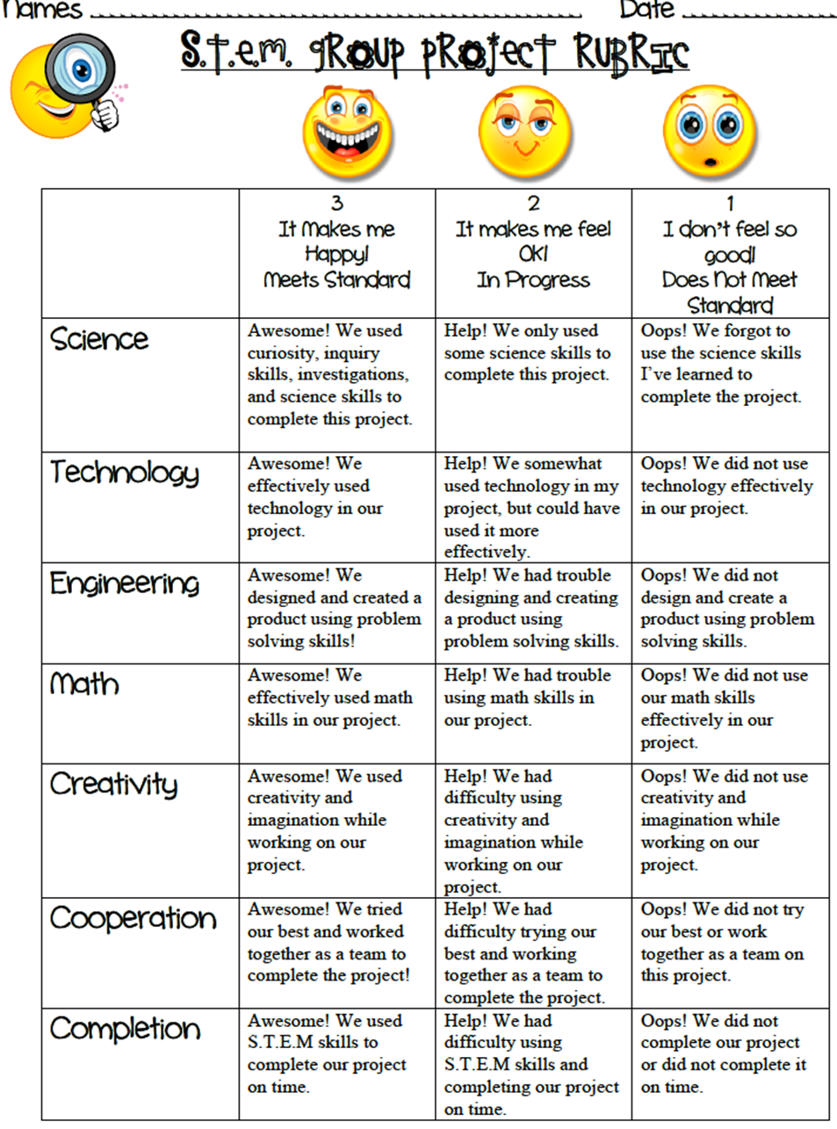

Name:___________________
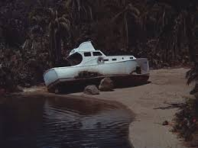
Saving the Crew of the Minnow (Gilligan’s Island)
STEM Challenge
2nd Grade

Challenge:
Your group will collaboratively build a sailboat that will safely carry all seven passengers without falling into the water using wind energy.
Criteria:
- Your boat must carry all seven passengers.
- Your boat must use wind energy.
- Your boat must have a shape with 6 equal faces, a shape with 3 equal angles, and a quadrilateral.
- Your boat must travel from one side of the tub of water to the other side.
- Create an island, background, and ocean floor in your tub.
Constraints:
- You may only use the provided materials.
- You must work together as a team.
- None of your passengers can fall into the water.
Materials:
corks, small plastic storage containers, craft sticks, construction paper, thin fabric, thick fabric, straws or thin dowels, glue, rubber bands, small fan or hair dryer, play dough, 7 small plastic bears, string, weighted objects that sink

- ASK / ENGAGE: What is the problem you are being asked to solve?
________________________________________________________________________________________________________________________________________________________________________________________________________________________________________________________________________________________________________________________________________________________________________________________________________
- IMAGINE/BRAINSTORM: What are some possible solutions to the problem that you are trying to solve? After you brainstorm, draw and label your ideas below.
Idea #1 | Idea #2
- PLAN/DESIGN: Share your ideas with your group and collaborate to decide on a final design plan. Draw your team’s design below and make a list of the materials that you will need to complete your design.
Team Design Plan | Materials List

- CREATE/TEST: Use your Final Design Plan to create and build your solution. Test your design. Did it work? Why or Why not?
____________________________________________________________________________________________________________________________________________________________________________________________________________________________________________________________________________________________________________________________________________________________________________________
- EVAULATE/IMPROVE: How well did your design work? Did your solution solve the problem within the given constraints?
____________________________________________________________________________________________________________________________________________________________________________________________________________________________________________________________________________________________________________________________________________________________________________________________________________________________________________________________________________________________________________________________________________________________________________________________________________________________________________
How can you improve your design? How can you make it better? Draw and label your improved design below.
Improved Design Plan

