Norton Park Elementary School
Science Fair Guidelines
General:
Registration QR Code: 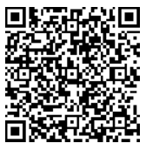
- Open to all K-5 students.
- You may work alone or with up to two partners making a group of three.
- Keep projects simple for the most fun.
- If working with a partner, both partners must be registered separately!
Registration
- Please register online at http://tinyurl.com/npksciencefair
- If you need a paper registration form please send your student to the STEM Lab and one will be sent home.
Project Limitations:
- No chemical reactions or volcanoes can be demonstrated at the school!
However, you may perform experiments at home (with parent supervision), document the data sand create a display based on that information.
- All demonstrations must be safe to display at school according to school guidelines.
- No knives may be brought to or used at school whether plastic or metal!
- No electricity will be available for the individual projects. They should be able to operate independently and battery power is fine to use.
- If you are unsure of the appropriateness of a project, please check with your teacher.
Displays:
- Your display must be free-standing and is limited to the size of the tri-fold display board. This type of board is available at most office supply stores or in the STEM Lab.
- Participants can use technology to help document data; however, an electrical outlet will not be available for your display.
Websites to check for ideas:
http://www.sciencebuddies.org/
http://www.science-fair-guide.com/default.asp
http://www.education.com/science-fair/elementary-school/

Project Set-up  4:30 PM-5:00 PM  •Please bring your project to school on the day of the science fair, during the set-up time only.  No early drop-off is available!  •Projects will be arranged on tables, by grade, in the order they are brought in.  - K-2nd in the Media Center  - 3rd- 5th in the Lunchroom | During the Science Fair  5:00 PM-6:30 PM  Be prepared to demonstrate your project and answer questions. You may walk around, but a parent and/or project partner should remain with each project to demonstrate it. All projects should be taken home at the end of the night.

*** If you have any further questions, please see Mrs. Ayres in the STEM Lab, email Gretchen.ayres@cobbk12.org or visit the Norton Park STEM Lab Blog http://nortonparkstem.weebly.com/.

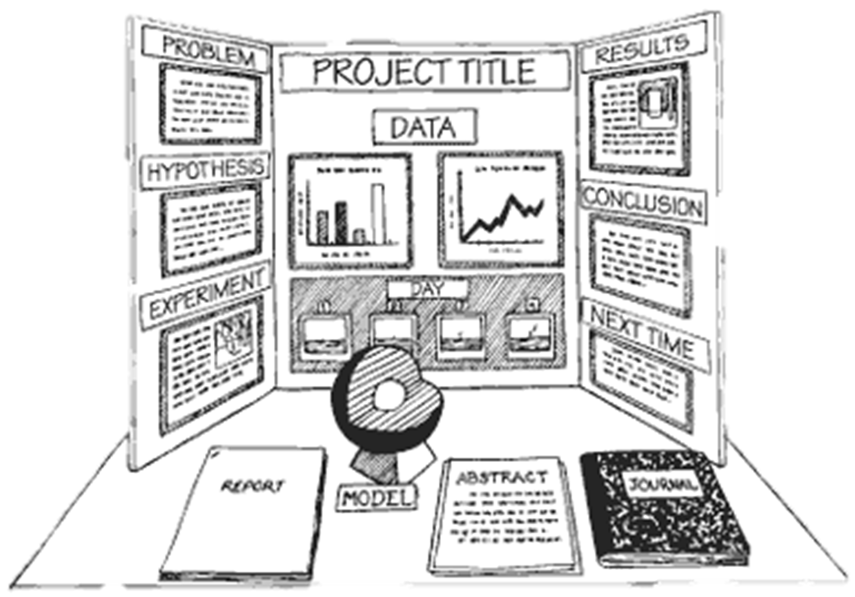
How should my project look?

